DIGITAL TWIN OF AN ELECTRIC VEHICLE

Authors: GHERMAN Antonio

MICHICIUC Viviana Gabriela Veronica

MOISE Roxana Teodora

DUMITRAȘCU Luca Georgian

FLORESCU Alin Constantin

# TASK 1: Identify the System, Its Form and Function

# TASK 2: Identify the entities of the system, their form and function and the system boundary and context

# Task 3: Identify the Relationships among the Entities

Interfaces define how system components communicate and work together, ensuring that the system as a whole works properly.

These interfaces are divided into two categories:

1. FUNCTIONAL RELATIONSHIPS (DYNAMIC)

The **dynamic relationship** between components describe how entities flow through different parts of the system.

1. Electricity

Electricity is the only operand present in the system and it is used by the car in order to function, almost all the components utilize this operand in different ways. For instance, the electric motor draws energy from the battery to power the car. This example shows the way in which energy is conducted through the wires. Another example can be the charging station and the charging socket of the car, when the electric car is plugged into a charging station, the car’s battery charges, so the electricity was moving through these components.

1. Controls and display

The driver interacts with the car using controls such as buttons, levers, or a touch screen display, enabling them to control various functions of the car.

1. The rotation mechanism of the wheels

The driver controls the steering wheel, which dynamically influences the steering ofthewheels, changing the car’s direction.

1. FORMAL RELATIONSHIPS (STATIC) (=STRUCTURE)

The **static relationships** represent the physical and structural components of the system that remain unchanged during operation.

1. Wires

Electricity flows through the wires to various components like the motor and display. The wires form a static structure, defining the paths for energy transmission.

1. Trunk

The trunk is a static structural component used to store objects, remaining fixed in the car’s design.

1. Structural entities

These include the chassis and the body of the car. The chassis provides the support framework for the car, while the body gives it shape.

1. Steering wheel

The steering wheel is used by a person to change the direction of the car, but its physical presence remains a static part of the car's structure.

1. Cabin

It is the place where people are accomodated. It remains also fixed in design.

Sketch with entities in squares:

Etc...

Circuits

Sensors

Electricity

Wires

Infotaintment

Air conditioning system

Soundproofing system

Etc...

Chairs

Engine

Outer body

Cabin

The electric vehicle system

# Task 4: Predicting Emergence

**Intended Emergence**

Function: Efficient and sustainable transportation.

Functional Interaction Description: The electric motor uses energy stored in the battery pack to propel the vehicle. Power electronics (inverters/converters) regulate the energy flow, and the battery management system (BMS) optimizes battery performance and longevity. Together, these components interact to deliver efficient propulsion, enabling the car to move smoothly and sustainably.

**Unintended Emergence**

Function: Overheating of battery cells.

Functional Interaction Description: In certain conditions, such as long drives or high-speed operation, the thermal management system may be insufficient. Excessive heat generated by the battery pack during heavy use could lead to accelerated cell degradation or safety risks like battery fires. The interaction between heat dissipation and battery management may fail, leading to unintended consequences.

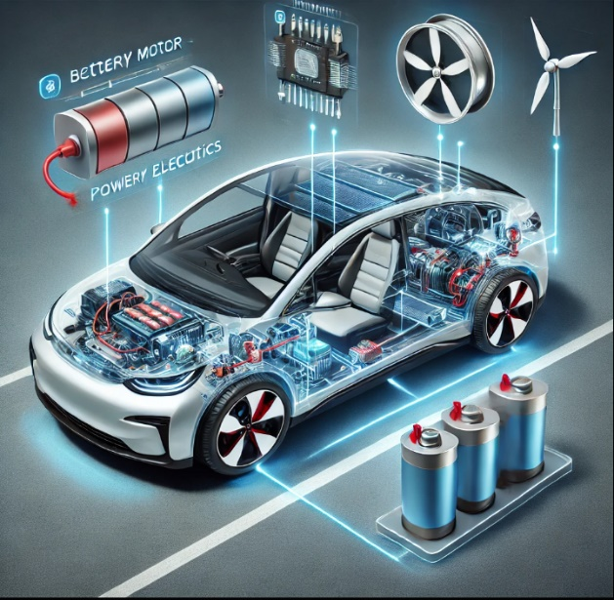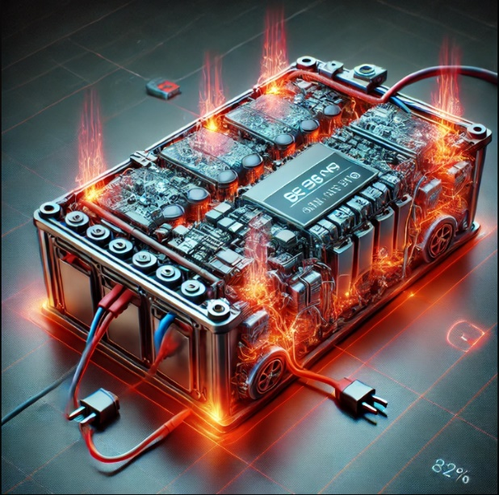Photo: (I'll generate an image of a battery overheating situation).

Figure 1 nu e 1 e 4 -Intended emergence

Figure 2 nu e 2 e 5 - Unintended emergence